**EXPERIMENT 1** :- THRESHOLD FREQUENCY = 40

--------------- **RAINFALL NOT NORMALISED | LINEAR KERNEL FUNCTION**  ---------------

|  |  |  |  |
| --- | --- | --- | --- |
| **INPUT** | | **MODEL** | |
| TRAINING SET | INSTANCES FROM 1 TO 3904 OF EXTMAT | SUPPORT VECTOR MACHINE REGRESSION MODEL | |
| TARGET FOR THE TRAINING SET | INSTANCES FROM 2 TO 3905 OF rain_mum_1969_2007_1grid | TRAINING | * mdl = fitrsvm(X,Y) * Trained using the predictor values in the matrix X and the response values in the vector Y * X[3904 x 1595]=instances from 1 to 3904 of EXTMAT * Y[3904 x 1]=instances from 2 to 3905 of rain_mum_1969_2007_1grid |
| TEST SET | INSTANCES FROM 3905 TO 4757 OF EXTMAT | PREDICTING | * yfit = predict(mdl,Xp) * Xp is the Test set * Xp[853 x 1595]=instances from 3905 to 4757 of EXTMAT |
| TARGET FOR THE TEST SET | INSTANCES FROM 3906 TO 4758 OF rain_mum_1969_2007_1grid | TESTING | * err = immse(yfit,Yp) = **602.9604** * err is the Mean Square Error * yfit[853 x 1]=predicted values on the Test set * Yp[853 x 1]=instances from 3906 to 4758 of rain_mum_1969_2007_1grid |

PLOTTING : plot(yfit,'r')

hold on;

plot(Yp,'g')

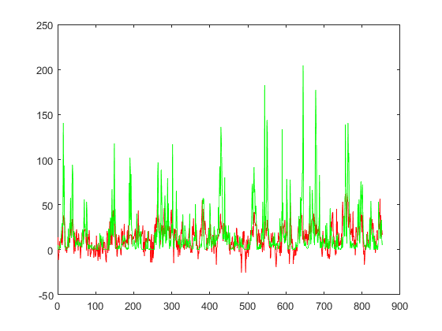

--------------- **RAINFALL NORMALISED | LINEAR KERNEL FUNCTION**  ---------------

|  |  |  |  |
| --- | --- | --- | --- |
| **INPUT** | | **MODEL** | |
| TRAINING SET | INSTANCES FROM 1 TO 3904 OF EXTMAT | SUPPORT VECTOR MACHINE REGRESSION MODEL | |
| TARGET FOR THE TRAINING SET | INSTANCES FROM 2 TO 3905 OF rain_mum_1969_2007_1grid_norm | TRAINING | * mdl1 = fitrsvm(X1,Y1) * Trained using the predictor values in the matrix X1 and the response values in the vector Y1 * X1[3904 x 1595]=instances from 1 to 3904 of EXTMAT * Y1[3904 x 1]=instances from 2 to 3905 of rain_mum_1969_2007_1grid_norm |
| TEST SET | INSTANCES FROM 3905 TO 4757 OF EXTMAT | PREDICTING | * yfit1 = predict(mdl1,Xp1) * Xp1 is the Test set * Xp1[853 x 1595]=instances from 3905 to 4757 of EXTMAT |
| TARGET FOR THE TEST SET | INSTANCES FROM 3906 TO 4758 OF rain_mum_1969_2007_1grid_norm | TESTING | * err1= immse(yfit1,Yp1) = **0.0142** * err1 is the Mean Square Error * yfit1[853 x 1]=predicted values on the Test set * Yp1[853 x 1]=instances from 3906 to 4758 of rain_mum_1969_2007_1grid_norm |

PLOTTING : plot(yfit1,'r')

hold on;

plot(Yp1,'g')

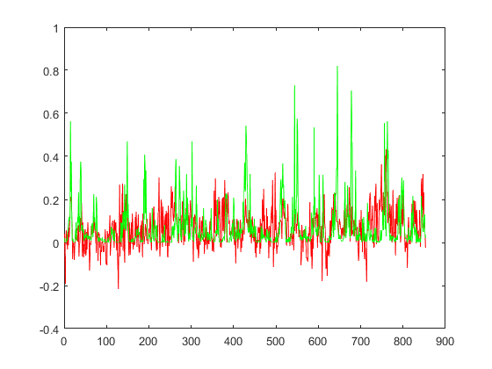

--------------- **RAINFALL NORMALISED | GAUSSIAN KERNEL FUNCTION**  ---------------

|  |  |  |  |
| --- | --- | --- | --- |
| **INPUT** | | **MODEL** | |
| TRAINING SET | INSTANCES FROM 1 TO 3904 OF EXTMAT | SUPPORT VECTOR MACHINE REGRESSION MODEL | |
| TARGET FOR THE TRAINING SET | INSTANCES FROM 2 TO 3905 OF rain_mum_1969_2007_1grid_norm | TRAINING | * mdl2 = fitrsvm(X1,Y1,’KernelFunction’,’gaussian’) * Trained using the predictor values in the matrix X1 and the response values in the vector Y1 * X1[3904 x 1595]=instances from 1 to 3904 of EXTMAT * Y1[3904 x 1]=instances from 2 to 3905 of rain_mum_1969_2007_1grid_norm |
| TEST SET | INSTANCES FROM 3905 TO 4757 OF EXTMAT | PREDICTING | * yfit2 = predict(mdl2,Xp1) * Xp1 is the Test set * Xp1[853 x 1595]=instances from 3905 to 4757 of EXTMAT |
| TARGET FOR THE TEST SET | INSTANCES FROM 3906 TO 4758 OF rain_mum_1969_2007_1grid_norm | TESTING | * err2= immse(yfit2,Yp1) = **0.0122** * err2 is the Mean Square Error * yfit2[853 x 1]=predicted values on the Test set * Yp1[853 x 1]=instances from 3906 to 4758 of rain_mum_1969_2007_1grid_norm |

PLOTTING : plot(yfit2,'r')

hold on;

plot(Yp1,'g')

